|  |  |  |  |  |  |  |  |  |
| --- | --- | --- | --- | --- | --- | --- | --- | --- |
| Sunday | | [http://downloadclipart.org/do-upload/clipart/2015-10/Halloween_bat_clipart.png](http://www.google.com/url?sa=i&rct=j&q=&esrc=s&source=images&cd=&cad=rja&uact=8&ved=0ahUKEwj7x_LOmdbOAhUB3GMKHRZiCyoQjRwIBw&url=http://downloadclipart.org/halloween-213&bvm=bv.129759880,d.cGc&psig=AFQjCNFQt5sXiSPzUs9pxLt8kN4S_9FHJA&ust=1471995507078667)Monday | Tuesday | Wednesday | | Thursday | [http://downloadclipart.org/do-upload/clipart/2015-10/Halloween_bat_clipart.png](http://www.google.com/url?sa=i&rct=j&q=&esrc=s&source=images&cd=&cad=rja&uact=8&ved=0ahUKEwj7x_LOmdbOAhUB3GMKHRZiCyoQjRwIBw&url=http://downloadclipart.org/halloween-213&bvm=bv.129759880,d.cGc&psig=AFQjCNFQt5sXiSPzUs9pxLt8kN4S_9FHJA&ust=1471995507078667)Friday | Saturday |
| **1**  10:00 Sing-along  10:30 Basketball  1:30 BlackJack | **2**  10:00 BINGO  1:30 Music Therapy | | **3**  10:00 Bullseye Toss  1:30 Manicure Day | **4**  10:00 BINGO  1:30 Movie Day | **5**  10:00 Ring Toss  11:00 Resident Council  1:30 Hanafuda | | **6**  10:00 BINGO  1:30 Word Games | **7**  10:00 Karaoke Time!  11:00 Table Games  1:30 Beachball Toss |
| **8**  10:00 Singing Therapy  11:00 Travel Video  1:30 Card Games | | **9**  10:00 Bingo  1:30 Casino Games | **10**  10:00 Woodcraft  Painting  1:30 Picture Match | **11**  10:00 Bingo  1:30 Jigsaw Puzzle | | **12** Nat’l. Pulled Pork Day!  10:00 How to make  Pulled Pork Sliders.  1:30 Toss Ball | **[http://downloadclipart.org/do-upload/clipart/2015-10/Halloween_bat_clipart.png](http://www.google.com/url?sa=i&rct=j&q=&esrc=s&source=images&cd=&cad=rja&uact=8&ved=0ahUKEwj7x_LOmdbOAhUB3GMKHRZiCyoQjRwIBw&url=http://downloadclipart.org/halloween-213&bvm=bv.129759880,d.cGc&psig=AFQjCNFQt5sXiSPzUs9pxLt8kN4S_9FHJA&ust=1471995507078667)13**  10:00 Bingo  1:30 Movie Day | **[http://images.clipartpanda.com/halloween-clipart-Cute-halloween-clipart-clipart-free-clipart-images-free-clipart-2.png](http://www.google.com/url?sa=i&rct=j&q=&esrc=s&source=images&cd=&cad=rja&uact=8&ved=0ahUKEwivlYbgmNbOAhUEwmMKHVvOAFQQjRwIBw&url=http://www.clipartpanda.com/categories/halloween-clipart&bvm=bv.129759880,d.cGc&psig=AFQjCNFQt5sXiSPzUs9pxLt8kN4S_9FHJA&ust=1471995507078667)14**  10:00 Sing-along  10:30 Ring Toss  1:30 Mini Games |
| **[http://images.clipartpanda.com/halloween-clipart-Cute-halloween-clipart-clipart-free-clipart-images-free-clipart-2.png](http://www.google.com/url?sa=i&rct=j&q=&esrc=s&source=images&cd=&cad=rja&uact=8&ved=0ahUKEwivlYbgmNbOAhUEwmMKHVvOAFQQjRwIBw&url=http://www.clipartpanda.com/categories/halloween-clipart&bvm=bv.129759880,d.cGc&psig=AFQjCNFQt5sXiSPzUs9pxLt8kN4S_9FHJA&ust=1471995507078667)15**  10:00 Karaoke Time  10:30 Going Down  Memory Lane  1:30 Word Games | | **16**  10:00 Bingo  [http://images.clipartpanda.com/pumpkin-border-clipart-halloween_pumpkin_jack_o_lantern_2.png](http://www.google.com/url?sa=i&rct=j&q=&esrc=s&source=images&cd=&cad=rja&uact=8&ved=0ahUKEwjQqtCpmNbOAhUKxmMKHSqkDBkQjRwIBw&url=http://www.clipartpanda.com/categories/fall-pumpkin-border&bvm=bv.129759880,d.cGc&psig=AFQjCNEaOB3tRSMWRFUPsBRPhU13ds6iXg&ust=1471995395736085)1:30 Color Therapy | **[http://images.clipartpanda.com/halloween-clipart-Cute_halloween_clipart.png](http://www.google.com/url?sa=i&rct=j&q=&esrc=s&source=images&cd=&cad=rja&uact=8&ved=0ahUKEwia2Z-Zm9bOAhVD1WMKHallAzwQjRwIBw&url=http://www.clipartpanda.com/categories/halloween-clipart&bvm=bv.129759880,d.cGc&psig=AFQjCNEf24pE-YhiAfjAIiMPuOLI3CYLPw&ust=1471996161734799)17**  10:00 Buddhist Service  11:00 Travel Video  1:30 Manicure Day | **18** National Chocolate  Cupcake Day!  10:00 Bingo  1:30 Music Therapy | | **19**  10:00 Bingo  1:30 Picture Match | **20**  10:00 Music with Roy  1:30 Massage Therapy | **21**  10:00 Karaoke Time  10:30 Basketball  1:30 Card Games |
| **22**  10:00 Singing Therapy  10:30 Let’s Go Fishing  [http://images.clipartpanda.com/halloween-clipart-Cute-halloween-clipart-clipart-free-clipart-images-free-clipart-2.png](http://www.google.com/url?sa=i&rct=j&q=&esrc=s&source=images&cd=&cad=rja&uact=8&ved=0ahUKEwivlYbgmNbOAhUEwmMKHVvOAFQQjRwIBw&url=http://www.clipartpanda.com/categories/halloween-clipart&bvm=bv.129759880,d.cGc&psig=AFQjCNFQt5sXiSPzUs9pxLt8kN4S_9FHJA&ust=1471995507078667)1:30 Game Day | | **23**  10:00 Bingo  1:30 Toss Ball | **24**  10:00 Horse Race  1:30 Arts & Crafts | **25**  10:00 Bingo  1:30 Jigsaw Puzzles | | **26**  Birthday Party  10:00 Birthday Tea Party  1:30 Movie Day | **27**  10:00 Bingo  1:30 Hanafuda | **28** **Trick or Treat**  10:00 Sing-along  10:30 Movie Day 1:00 Trick or Treat  With HHA Ohana |
| **29**  10:00 Karaoke Time  10:30 Bullseye Toss  1:30 Arts & Crafts | | **30**  10:00 Bingo  1:30 Halloween Trivia | **31** **Happy Halloween!**  10:00 Halloween  Cookie Decoration  [http://images.clipartpanda.com/halloween-clipart-Cute_halloween_clipart.png](http://www.google.com/url?sa=i&rct=j&q=&esrc=s&source=images&cd=&cad=rja&uact=8&ved=0ahUKEwia2Z-Zm9bOAhVD1WMKHallAzwQjRwIBw&url=http://www.clipartpanda.com/categories/halloween-clipart&bvm=bv.129759880,d.cGc&psig=AFQjCNEf24pE-YhiAfjAIiMPuOLI3CYLPw&ust=1471996161734799)1:30 Manicure Day | [http://downloadclipart.org/do-upload/clipart/2015-10/Halloween_bat_clipart.png](http://www.google.com/url?sa=i&rct=j&q=&esrc=s&source=images&cd=&cad=rja&uact=8&ved=0ahUKEwj7x_LOmdbOAhUB3GMKHRZiCyoQjRwIBw&url=http://downloadclipart.org/halloween-213&bvm=bv.129759880,d.cGc&psig=AFQjCNFQt5sXiSPzUs9pxLt8kN4S_9FHJA&ust=1471995507078667)[http://images.clipartpanda.com/pumpkin-border-clipart-halloween_pumpkin_jack_o_lantern_2.png](http://www.google.com/url?sa=i&rct=j&q=&esrc=s&source=images&cd=&cad=rja&uact=8&ved=0ahUKEwjQqtCpmNbOAhUKxmMKHSqkDBkQjRwIBw&url=http://www.clipartpanda.com/categories/fall-pumpkin-border&bvm=bv.129759880,d.cGc&psig=AFQjCNEaOB3tRSMWRFUPsBRPhU13ds6iXg&ust=1471995395736085)Free Halloween Animations - Animated Halloween Gifs - ClipartDAILY ACTIVITIES  9:00 Morning Exercise  9:30 Morning Social & Headlines/News  1:30 to 2:30 In-room Visits/1:1 Bedside Activities  [http://images.clipartpanda.com/halloween-clipart-Cute-halloween-clipart-clipart-free-clipart-images-free-clipart-2.png](http://www.google.com/url?sa=i&rct=j&q=&esrc=s&source=images&cd=&cad=rja&uact=8&ved=0ahUKEwivlYbgmNbOAhUEwmMKHVvOAFQQjRwIBw&url=http://www.clipartpanda.com/categories/halloween-clipart&bvm=bv.129759880,d.cGc&psig=AFQjCNFQt5sXiSPzUs9pxLt8kN4S_9FHJA&ust=1471995507078667)[http://images.clipartpanda.com/halloween-clipart-Cute_halloween_clipart.png](http://www.google.com/url?sa=i&rct=j&q=&esrc=s&source=images&cd=&cad=rja&uact=8&ved=0ahUKEwia2Z-Zm9bOAhVD1WMKHallAzwQjRwIBw&url=http://www.clipartpanda.com/categories/halloween-clipart&bvm=bv.129759880,d.cGc&psig=AFQjCNEf24pE-YhiAfjAIiMPuOLI3CYLPw&ust=1471996161734799)10:00 & 2:00 Snack Time  3:00 Namaste  10:00 to 1:30 Please refer to this calendar | | | | |

[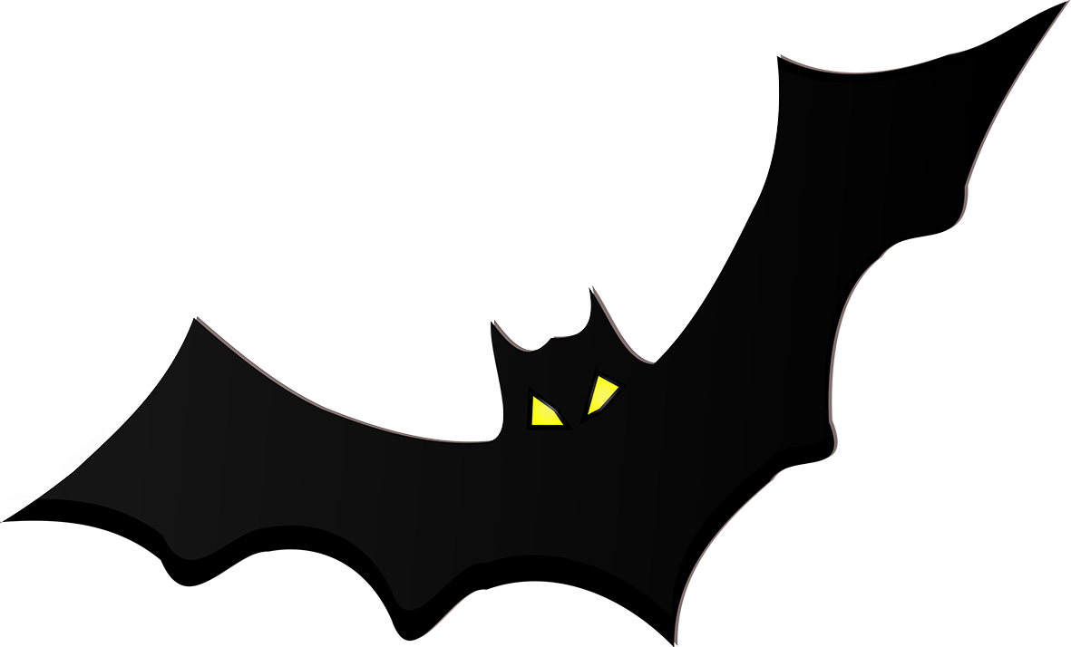](http://www.google.com/url?sa=i&rct=j&q=&esrc=s&source=images&cd=&cad=rja&uact=8&ved=0ahUKEwj7x_LOmdbOAhUB3GMKHRZiCyoQjRwIBw&url=http://downloadclipart.org/halloween-213&bvm=bv.129759880,d.cGc&psig=AFQjCNFQt5sXiSPzUs9pxLt8kN4S_9FHJA&ust=1471995507078667)